University of Bern

SRS - Team 4 ESE 2016

Software Requirements Specification Document

Balthasar Hofer, Flurin Trübner, Kevin Meister, Sven Schmid, Ramona Beck

**Version:** 1

**Date:** 08.10.2016

#### Contents

1. Revision History

|  |  |  |
| --- | --- | --- |
| **Version** | **Date** | **Description** |
| 01 | 08.10.2016 | Document initialized and structured. |
| 02 |  |  |
| … |  |  |
|  |  |  |

1. Introduction

## Purpose

The purpose of this project is to create a website for users to search for rooms and roommates. This SRS should give a detailed overview of all aspects of the whole project. It is intended to clarify and capture the requirements of the customer and to work as a contract between the customer and the ese-team 4.

## Stakeholders

The stakeholders of this projects are the ESE 2016 staff, for team 4 especially „NameOfAssistant“.

## Definitions

**Registered User:** A person that is already registered on the website; this person uses the website for its intended purpose.

**Unregistered User:** A person that uses the website for its intended purpose but is not yet registered.

**Premium User:**

**Normal User:**

**Ad:** A specific site on the website where the advertiser can publish detailed information about a room which is for rent. The ad can be seen from any user.

**Advertiser:** A registered user that already has placed (or wants to place) one or multiple ad on the website

**Searcher:** Any user who is looking for ads on the website

## System Overview

The software system is a website which helps users to find a room or a person to share an apartment with. The system should assist a user to find the optimal ad by matching various criteria of the user’s preferences and the ads specifications. Furthermore, the system should provide the users a way to communicate with advertiser to arrange appointments.

## References

## Overview

The rest of the SRS contains the overall description in section 2 as well as the specific requirements in section 3.

Section 2 is most important to the customers and potential users since it describes the system from the user perspective. This is mostly done by describing different use cases and typical user scenarios.

Section 3 is most important to the developers since this section describes the functionality of the system. That means, this section covers all aspects that are needed to fulfil the scenarios described in section 2. Furthermore, all additional requirements are specified in this section.

1. Overall Description

## Overview Diagrams

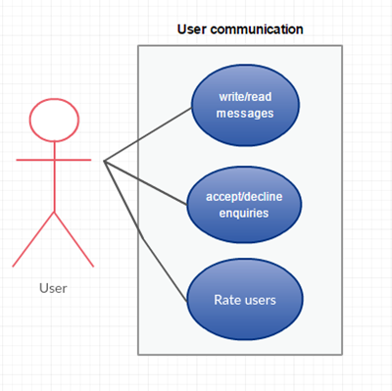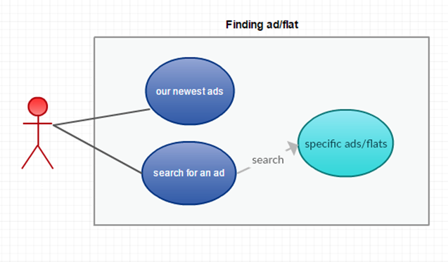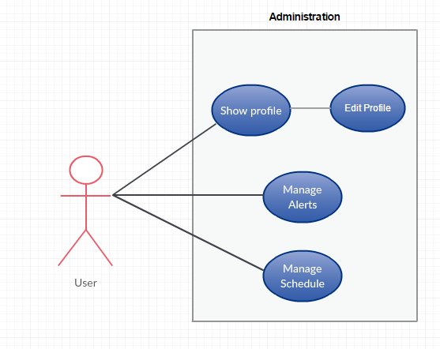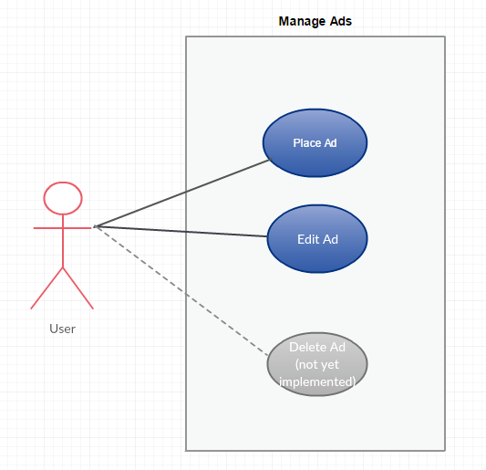

## Advertiser Use Cases

## Place an ad

|  |  |
| --- | --- |
| **Actor** | Registered User |
| **Description** | As a registered user I want to be able to place an ad |
| **Trigger** |  |
| **Precondition** | 1. User has access to the internet 2. The user owns an account on the website 3. The user knows his e-mail address and password to be able to log in 4. The user is logged in |
| **Basic** **Flow** | 1. The user navigates to the „place an ad“ page 2. The user fills in the form 3. The user submits the ad 4. The ad will be placed on the „My advertisements“ list |
| **Alternative** **Flow** | 1. The user provides invalid information  * The user will have to fill in the form again  1. The user loses access to the internet while filling in the form  * The user has to start from beginning |
| **Specific** **Requirements** | none |
| **Notes** | How does the form look exactly? What criteria should be provided? |

## Edit ad

|  |  |
| --- | --- |
| **Actor** | Registered User |
| **Description** | As a registered user I want to be able to edit my ads |
| **Trigger** |  |
| **Precondition** | 1. User has access to the internet 2. The user owns an account on the website 3. The user knows his e-mail address and password to be able to log in 4. The user is logged in 5. The user has already placed an ad |
| **Basic** **Flow** | 1. The user moves to the „My rooms“ site 2. The user gets an abstract of all his ads 3. The user selects the ad he wants to edit 4. The user clicks on the „Edit ad“ shortcut 5. The system redirects the user to the „Edit ad“ site 6. The user changes the information he wants to change 7. The user submits the changes 8. The system saves the adjusted ad |
| **Alternative** **Flow** | 1. The user loses access to the internet as he adjusts the ad    1. The user has to start from beginning |
| **Specific** **Requirements** | none |
| **Notes** | none |

## Delete ad (not yet implemented)

|  |  |
| --- | --- |
| **Actor** | Registered User |
| **Description** | As a registered user I want to be able to delete my ads |
| **Trigger** |  |
| **Precondition** | 1. User has access to the internet 2. The user owns an account on the website 3. The user knows his e-mail address and password to be able to log in 4. The user is logged in 5. The user has already placed an ad |
| **Basic** **Flow** |  |
| **Alternative** **Flow** |  |
| **Specific** **Requirements** |  |
| **Notes** | Where should the shortcut „Delete ad“ be placed? Should the user confirm that he really wants to delete the ad? Should it be possible to delete several ads at once? |

## Manage enquiries

|  |  |
| --- | --- |
| **Actor** | Registered User |
| **Description** | As a registered user who placed at least one ad I want to be able to see an overview of all my enquiries, as well as being able to accept or decline them. |
| **Trigger** |  |
| **Precondition** | 1. User has access to the Internet 2. The user owns an account on the website 3. The user knows his e-mail address and password to be able to log in 4. The user is logged in 5. The user has already placed an ad 6. To be able to manage them, the user needs to have at least one enquiry |
| **Basic** **Flow** | 1. The user moves to the „Enquiries“ site 2. The user gets an overview of all his enquiries 3. The user either accepts or declines the new enquiries |
| **Alternative** **Flow** | 1. The user neither accepts nor declines an enquiry before its scheduled date    1. Nothing happens |
| **Specific** **Requirements** | none |
| **Notes** | What should happen if the advertiser doesn’t accept or decline an enquiry before it’s due? |

## Manage schedule

|  |  |
| --- | --- |
| **Actor** | Registered User |
| **Description** | As a registered user I want to see a schedule of all my presentations (visitors of my flat) and all the visits I’ve realized in the past. The schedule must provide an overview that contains the address of the concerning flat, the date and time of the visit and a link to the ad-website. In the schedule of my presentations I want an additional link to see a list of all the visitors of a flat. |
| **Trigger** |  |
| **Precondition** | 1. The user has access to the internet 2. The user has an account on the website 3. The user is logged in |
| **Basic** **Flow** | 1. User moves to the schedule page 2. The user gets an overview of the scheduled presentations as well as of the scheduled visits of the past. |
| **Alternative** **Flow** |  |
| **Specific** **Requirements** | none |
| **Notes** | Are visits shown only from the past, or from the future as well? |

## Compile a list of the most promising candidates

|  |  |
| --- | --- |
| **Actor** | Registered User |
| **Description** | As a registered user I want to create a visitable list of the most promising properties to get a better overview. Therefore, I want the possibility to bookmark the ad I’m visiting to add it to this list. |
| **Trigger** |  |
| **Precondition** | 1. User has access to the Internet 2. The user owns an account on the website 3. The user is logged in |
| **Basic** **Flow** | 1. The user searches a promising ad on the Home page or through the Search page by filling in the form 2. On the ads site the user can bookmark the ad with the bookmark button on the top right if it is not his own. |
| **Alternative** **Flow** |  |
| **Specific** **Requirements** |  |
| **Notes** | The list is found on the My room page and the bookmarks can be reversed with the same button as they were added. |

## Edit Profile

|  |  |
| --- | --- |
| **Actor** | Registered user |
| **Description** | After creating a profile, I want to be able to edit it |
| **Trigger** |  |
| **Precondition** | 1. The user has access to the internet 2. The user has an account on the website 3. The user is logged in |
| **Basic** **Flow** | 1. The user opens his public profile and clicks on „Edit Profile“ 2. The user gets all the information regarding his profile and is able to edit everything |
| **Alternative** **Flow** | 1. The deletes crucial information from his profile, such as his Username or First name    * An error occurs and the changes won’t be saved |
| **Specific** **Requirements** |  |
| **Notes** |  |

## Sell properties directly in an ad (new)

|  |  |
| --- | --- |
| **Actor** | Registered User |
| **Description** | As a registered user I want to sell properties directly in an ad. |
| **Trigger** |  |
| **Precondition** | 1. The user has access to the internet 2. The user has an account on the website 3. The user is logged in |
| **Basic** **Flow** | 1. The user moves to the “Place an ad” page 2. The user fills out the presented form and specifies a buyout price 3. The user submits the ad 4. The ad will be placed on the „My advertisements“ list on the My rooms page |
| **Alternative** **Flow** |  |
| **Specific** **Requirements** |  |
| **Notes** | The form must be adapted for direct sales. |

## Sell properties through an auction in an ad (new)

|  |  |
| --- | --- |
| **Actor** | Registered User |
| **Description** | As a registered user I want to sell properties as an auction in an ad. |
| **Trigger** |  |
| **Precondition** | 1. The user has access to the internet 2. The user has an account on the website 3. The user is logged in |
| **Basic** **Flow** | 1. The user moves to the “Place an ad” page 2. The user fills out the presented form and specifies an auction duration and a starting price with the option for an additional buyout price. 3. The user submits the ad 4. The ad will be placed on the „My advertisements“ list on the My rooms page |
| **Alternative** **Flow** |  |
| **Specific** **Requirements** |  |
| **Notes** | The form must be adapted for auctions.  What properties exactly? Do they have to satisfy certain criteria? |

## Searcher Use Cases

## Search for a room

|  |  |
| --- | --- |
| **Actor** | Anyone |
| **Description** | Anyone should be able to search for either a flat or room. Multiple search criteria can be used to narrow the search results |
| **Trigger** |  |
| **Precondition** | 1. The user has access to the internet |
| **Basic** **Flow** | 1. The user opens the search menu and fills out all the search criteria 2. After confirmation the results are displayed |
| **Alternative** **Flow** | 1. Some information was left blank    * An error occurs with the request to fill out the missing elements |
| **Specific** **Requirements** |  |
| **Notes** |  |

## Contact advertiser

|  |  |
| --- | --- |
| **Actor** | Registered User |
| **Description** | A registered user should be able to contact an advertiser to ask for more information about the ad or to enquire a meeting. |
| **Trigger** |  |
| **Precondition** | 1. The user has access to the internet 2. The user has an account on the website 3. The user is logged in |
| **Basic** **Flow** | 1. The user searches a promising ad on the Home page or through the Search page by filling in the form 2. On the ads site the user can contact the advertiser on the bottom of the ad’s page in the Advertiser frame |
| **Alternative** **Flow** |  |
| **Specific** **Requirements** |  |
| **Notes** |  |

## Send an enquiry

|  |  |
| --- | --- |
| **Actor** | Registered User |
| **Description** | As a registered user I want to enquire a meeting with the advertiser of an ad I’m interested in. |
| **Trigger** |  |
| **Precondition** | 1. The user has access to the internet 2. The user has an account on the website 3. The user is logged in |
| **Basic** **Flow** | 1. The user searches a promising ad on the Home page or through the Search page by filling in the form 2. On the ads site the user can send a timely fixed enquiry to the advertiser by clicking on the “Send enquiry to advertiser” button in the Visiting times frame. |
| **Alternative** **Flow** | 1. The user searches a promising ad on the Home page or through the Search page by filling in the form 2. On the ads site the user can contact the advertiser on the bottom of the ad’s page in the Advertiser frame to enquire an meeting. |
| **Specific** **Requirements** |  |
| **Notes** |  |

## Bookmark an ad

|  |  |
| --- | --- |
| **Actor** |  |
| **Description** |  |
| **Trigger** |  |
| **Precondition** |  |
| **Basic** **Flow** |  |
| **Alternative** **Flow** |  |
| **Specific** **Requirements** |  |
| **Notes** | Included in Compile a list of the most promising candidates? |

## Subscribe to alerts

|  |  |
| --- | --- |
| **Actor** | Registered User |
| **Description** | As a registered user I want to subscribe alerts for specific search filter criteria. So I will receive alerts if a new ad fulfills my search criteria. |
| **Trigger** |  |
| **Precondition** | 1. The user has access to the internet 2. The user has an account on the website 3. The user is logged in |
| **Basic** **Flow** | 1. The user moves to the “Alerts” page 2. The users fills in the search form and clicks on the Subscribe button below the search form |
| **Alternative** **Flow** |  |
| **Specific** **Requirements** |  |
| **Notes** | The active alerts are shown on the alerts page |

## Create search alert (new)

|  |  |
| --- | --- |
| **Actor** |  |
| **Description** |  |
| **Trigger** |  |
| **Precondition** |  |
| **Basic** **Flow** |  |
| **Alternative** **Flow** |  |
| **Specific** **Requirements** |  |
| **Notes** | Which differences compared to subscribe to alerts ? |

## Search for properties to sale (new)

|  |  |
| --- | --- |
| **Actor** | Anyone |
| **Description** | Anyone should be able to search advertised properties for sale. Multiple search criteria can be used to narrow the search results |
| **Trigger** |  |
| **Precondition** | 1. The user has access to the internet |
| **Basic** **Flow** | 1. The user opens the search menu and fills out all the search criteria 2. After confirmation the results are displayed |
| **Alternative** **Flow** |  |
| **Specific** **Requirements** |  |
| **Notes** | The search form must be adjusted for this search. |

## Other Use Cases

## Register on the website

|  |  |
| --- | --- |
| **Actor** | Unregisterd User |
| **Description** | Anyone should be able to register himself on the page to access the full features. |
| **Trigger** |  |
| **Precondition** | 1. The user has access to the internet 2. The user has an email account |
| **Basic** **Flow** | 1. The user moves to the “Login” page. 2. The user clicks on “sign up” to reach the “sign up” page 3. The user fills in the form to sign up and clicks on the “Sign up” button below the form. |
| **Alternative** **Flow** |  |
| **Specific** **Requirements** |  |
| **Notes** | Currently the email address must not be confirmed. So any address could be used for the login. |

## Login on the website

|  |  |
| --- | --- |
| **Actor** | Registered User |
| **Description** | As a registered user I want log in on the website to access all features. |
| **Trigger** |  |
| **Precondition** | 1. The user has access to the internet 2. The user has an account on the website |
| **Basic** **Flow** | 1. The users moves to the “Login” page 2. The user fills in his Email and Password and clicks on the “Login” button |
| **Alternative** **Flow** | 1. Visit the advertiser’s profile, where his email address is denoted 2. Write an email to the advertiser with any email client |
| **Specific** **Requirements** |  |
| **Notes** |  |

## Visit profile

|  |  |
| --- | --- |
| **Actor** | Registered User |
| **Description** | As a registered user I want to visit the profile of an advertiser to find out more about him. |
| **Trigger** |  |
| **Precondition** | 1. The user has access to the internet 2. The user has an account on the website 3. The user is logged in |
| **Basic** **Flow** | 1. The user searches a promising ad on the Home page or through the Search page by filling in the form 2. On the ads site the user can visit the advertiser’s profile |
| **Alternative** **Flow** | 1. The user moves to “Enquiries” page 2. The user can click on the usernames listed in the enquiries |
| **Specific** **Requirements** |  |
| **Notes** |  |

## Write Message

|  |  |
| --- | --- |
| **Actor** | Registered User |
| **Description** | As a registered user I want to write messages to other registered users especially to advertisers. |
| **Trigger** |  |
| **Precondition** | 1. The user has access to the internet 2. The user has an account on the website 3. The user is logged in |
| **Basic** **Flow** | 1. The user visits the profile of the desired user and clicks on the “Message button” and the message window opens 2. The user adds a subject and a message and clicks on “Send” |
| **Alternative** **Flow** | 1. The user moves to the “Messages” page and clicks on “New” on the left 2. The user adds a subject and a message and clicks on “Send” |
| **Specific** **Requirements** |  |
| **Notes** | This Basic Flow chosen because it seems to be the common way to send messages compared to the Alternative Flow |

## Read Message

|  |  |
| --- | --- |
| **Actor** | Registered User |
| **Description** | As a registered user I want to read the messages other users sent me. |
| **Trigger** |  |
| **Precondition** | 1. The user has access to the internet 2. The user has an account on the website 3. The user is logged in |
| **Basic** **Flow** | 1. The user moves to the “Messages” page and lands directly in the inbox to read and access received messages |
| **Alternative** **Flow** |  |
| **Specific** **Requirements** |  |
| **Notes** |  |

## Rate User

|  |  |
| --- | --- |
| **Actor** | Registered User |
| **Description** | As a registered user I want to rate users I met as a decision guidance |
| **Trigger** |  |
| **Precondition** | 1. The user has access to the internet 2. The user has an account on the website 3. The user is logged in 4. The user had presentations |
| **Basic** **Flow** | 1. The user moves to the “Schedule” page 2. The user clicks on the “See List” button in the Visitors column Below “Your Presentations” 3. The user can rate users in the Rating column |
| **Alternative** **Flow** |  |
| **Specific** **Requirements** |  |
| **Notes** |  |

## Actor characteristics

1. Specific requirements

## Functional Requirements

## Non-Functional Requirements

### Performance

### Safety

### Reliability

### Availability

### Security

### Usability

### Logical Structure of the Data